<https://www.metinfo.cn/download/>

We only conducted a simple judgment on whether there are the same users here

You can modify any user's password, personal information, etc. by constructing a poc

app\system\user\admin\admin_user.class.php doSaveUser()

Capture the packet (first 1), save it, and send it to the built-in CSRF construction module of BP

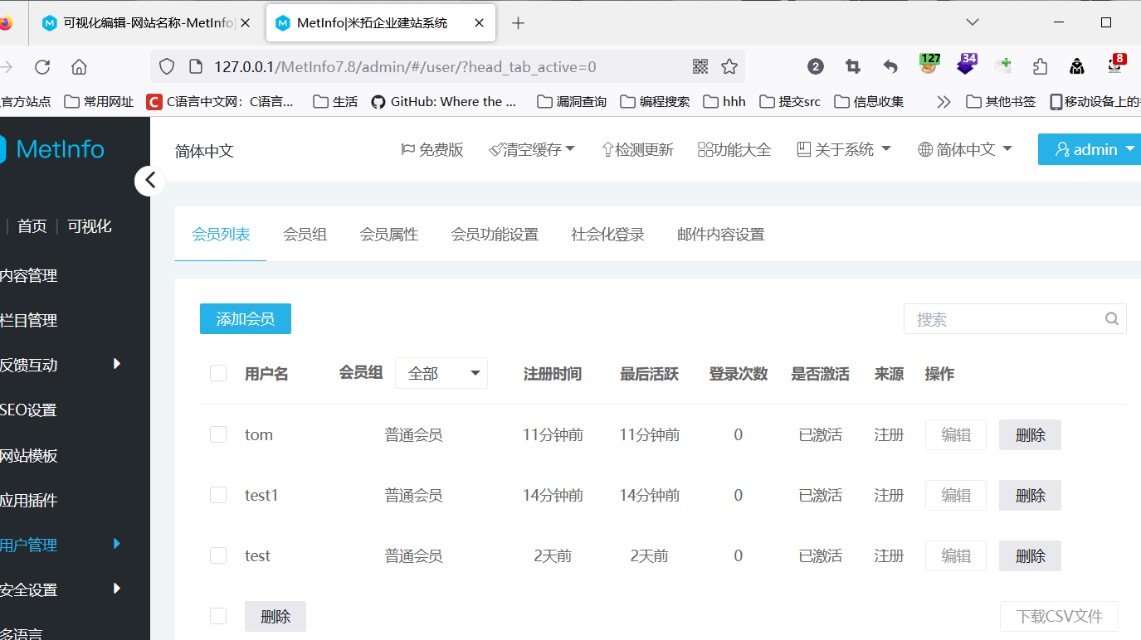

My Tom ID is 7. I will change this ID to 7, and other passwords can also be changed to 12345678. Remember to change your email address, otherwise it will be duplicated and there will be a phone number

You can modify the groupID to change whether it is a regular member or an agent. If you do not modify the ID, you will change the information of the user corresponding to the ID

My Tom's information is 123, and my password is 123456

Then log in to admin using a different browser to access 127.0.0.1/csrf.html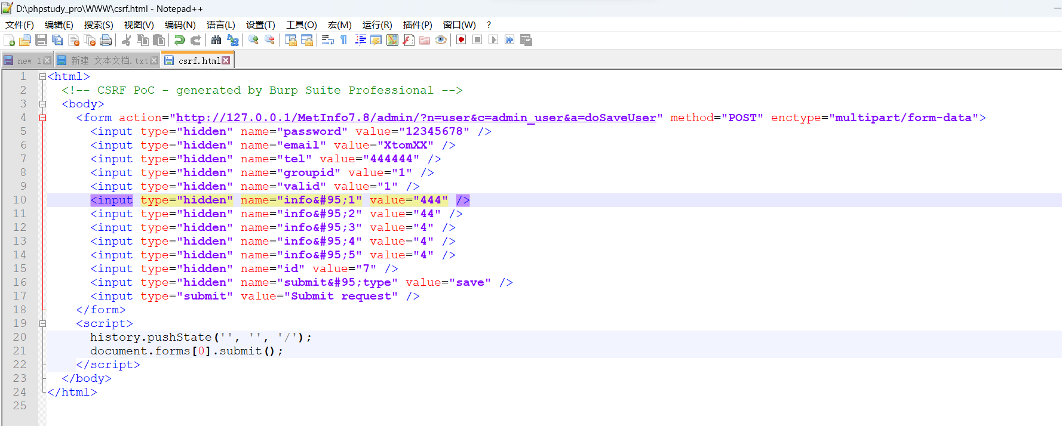



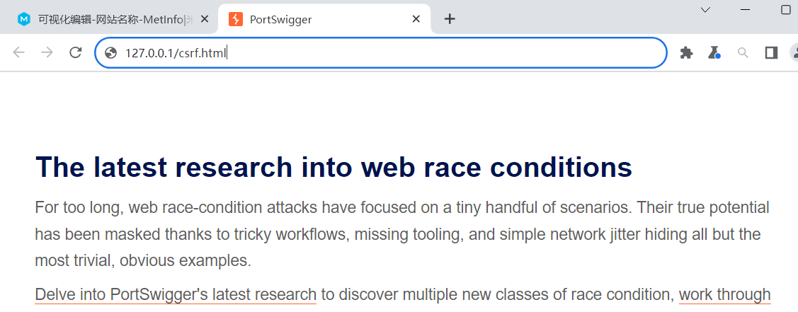

Successfully modified, and the password has also changed